Museum of You

Have you always wanted to show your artwork at The Beaney? Or do you have an interesting object at home that you would like to share a story about?

We believe that in these extraordinary times, the stories of ordinary people are more important than ever. Which is why we are inviting you to help us co-create an exhibition for our Front Room Gallery when we reopen. The Beaney is currently closed but we look forward to welcoming visitors back with an exhibition that will celebrate the creativity, stories and experiences of some of the most interesting people in the county - you!

Every fortnight we will be releasing a new theme on our website and in our museum newsletter to inspire you and give you ideas of art work you could make. We also welcome any creative response to the theme and invite you to be as imaginative as possible, using any medium - paintings, drawings, photographs, textiles, prints, mixed media and written responses are all welcome.

Who can submit?

Everyone has an interesting story to tell and submissions are open to everyone, of all ages, whether you are an established artist or getting creative for the first time. We welcome submissions from individuals as well as community groups, from new creatives and the continuously curious, to domestic Picassos and everyone in between.

Theme 2 - Be Mindful

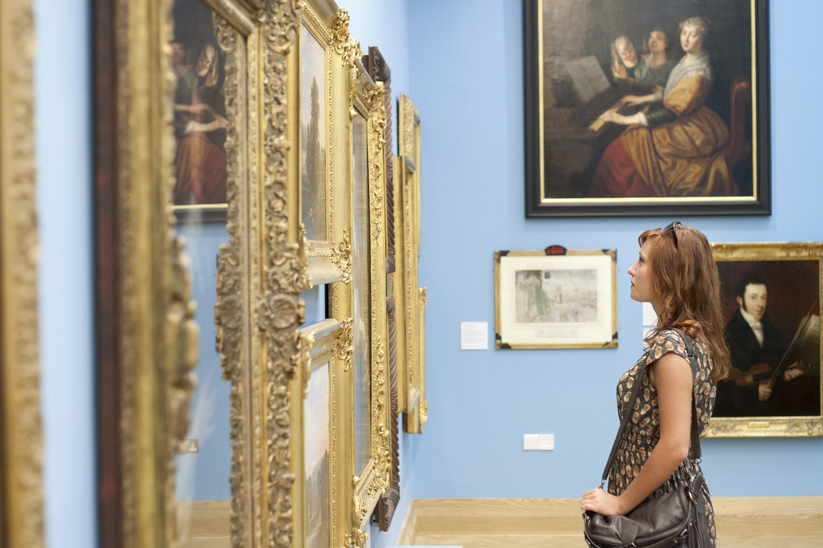

Being mindful is the act of being aware of and present in what you are doing, whatever that is. It can be something creative or an everyday activity. The only thing you have to do is to notice how you feel while you are doing something. Mindfulness has been proven to have benefits for wellbeing - not only does it enhance our experience of positive activities, it has also been shown to help us build a greater capacity for managing adverse events.

Suggested activity: Use creativity to ground yourself in the present moment. Create an artwork which represents where you are. This could be a painting of how you feel, a poem about your house, anything that shows where you are right now.

We welcome any creative response to the theme and invite you to be as imaginative as possible, using any medium - paintings, drawings, photographs, textiles, prints, mixed media and written responses are all welcome.

How to submit:
You can share your work with us on social media by tagging us @TheBeaney on Facebook, or @The_Beaney on Instagram and Twitter. Please us the hashtag #MuseumOfYou.

You can submit your stories and artworks by emailing them directly to Jemma.channing@canterbury.gov.uk

In your submission please include:

- A photo or scan of your artwork
- The title of your artwork
- A description of your work. This could include a description of how the work relates to the theme, how you felt while you were making it and what was happening while you were making it. (Word limit - 100 words)
- Your name
- Plus a contact email or phone number

Submissions must be received by Midday on Friday 29th May

Additional Guidelines:

Artists are invited to submit work for one, some or all of the themes.
Artwork can be in any medium including painting, drawing, print, photography, textiles or written.
Due to gallery restrictions we are unable to accept video submissions.
The maximum size we can accept for submissions is A2 (42 x 60cm).
Dates of exhibition to be confirmed.
Artists are responsible for dropping off and picking up artwork from The Beaney. Dates TBC

